
CO 4 ASSESSMENT TOOL 1
CSA0406 SOFTWARE ENGINEERING
NAME: Alima Banu R
REG NO:192471044

CI/CD Pipeline Design Document
Medication Adherence Tracker for Elderly Patients with Caregiver Alerts

Table of Contents
1. Project Analysis & CI/CD Needs 2
2. CI/CD Pipeline Workflow 2
Stage-by-stage summary 3
3. Tools & Technologies per Stage 3
4. Automated Testing Strategy 4
5. Deployment Strategy 4
6. Security, Quality Gates, Notifications & Rollback 5
6.1 Security & Quality Gates 5
6.2 Notifications 5
6.3 Rollback Mechanisms 5
7. Conclusion 6

1. Project Analysis & CI/CD Needs
- System composition: a patient-facing mobile app (Android/iOS), a caregiver web dashboard, a backend API (medication schedules, dose logging, escalation logic), a scheduler/notification service (push, SMS, email), and a database — so the pipeline must build and deploy multiple artifact types from one coordinated workflow.
- Frequent, safety-sensitive releases: reminder and escalation logic changes often and directly affects patient safety, so every change needs fast, automated, repeatable verification before reaching real users — manual releases are too slow and too risky.
- Multiple environments: changes must be verified progressively (Dev -> Staging -> Production) so that reminder timing and caregiver-alert accuracy are proven under production-like conditions before go-live.
- Regulatory/privacy sensitivity: the system stores patient health-adjacent data, so the pipeline must enforce security scanning, secrets management, and controlled production access.
- High reliability bar: NFRs require 99.9% reminder accuracy and 24x7 alert availability, so the pipeline needs automated regression, performance, and health-check-gated deployment with automatic rollback.

2. CI/CD Pipeline Workflow
Figure 1 shows the full workflow from a developer's commit through to a monitored production release.
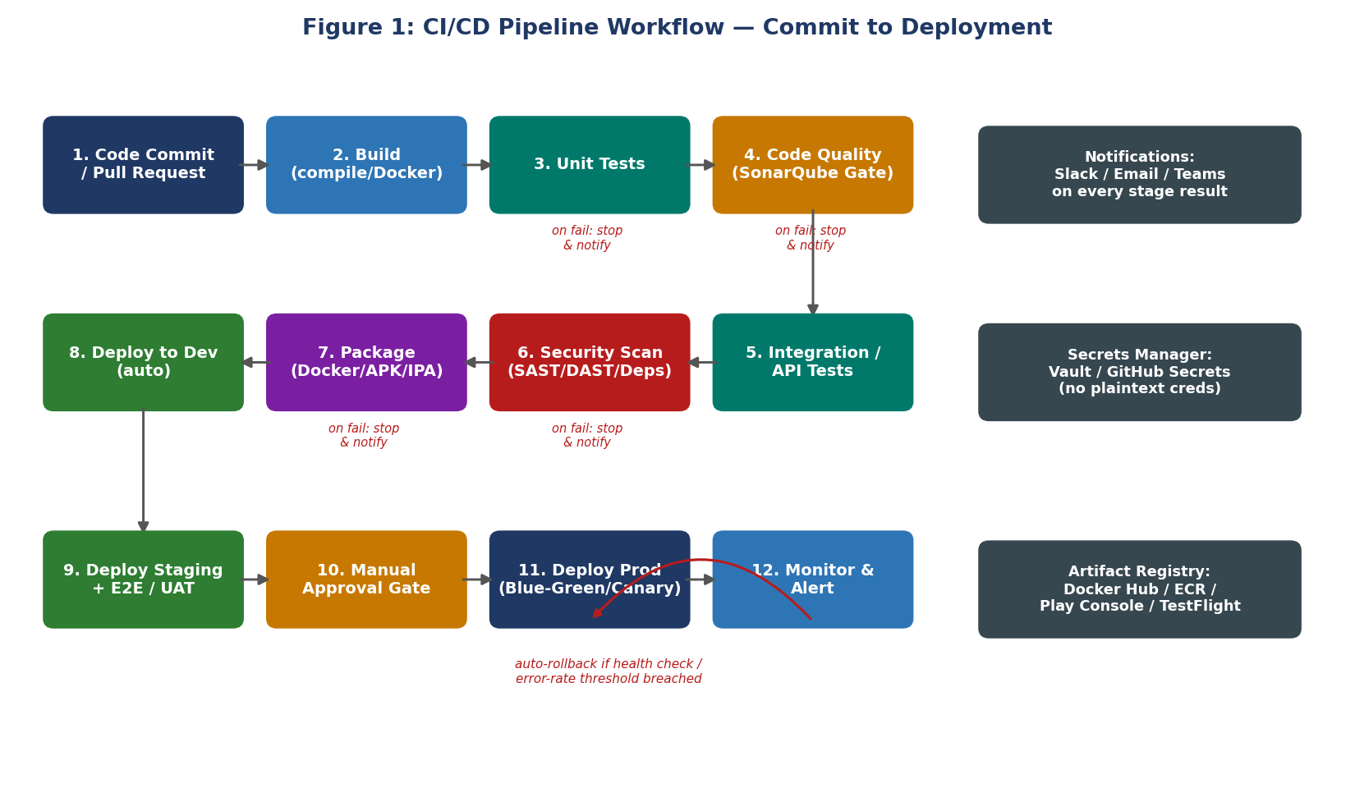
Figure 1: CI/CD pipeline stages — source control, build, test, quality gate, security scan, package, and staged deployment.

Stage-by-stage summary
- 1-2. Commit & Build: a pull request triggers the pipeline; the backend, web dashboard, and mobile app are each built (compiled / Docker image / APK-IPA).
- 3-4. Unit Test & Code Quality: unit tests run first (fastest feedback); SonarQube then enforces a quality gate (coverage, duplication, code smells) before proceeding.
- 5-6. Integration & Security: API/integration tests exercise real service interactions (e.g., scheduling a dose and verifying an alert is queued); SAST, dependency, and secret scans run in parallel.
- 7-8. Package & Deploy Dev: artifacts are versioned and pushed to a registry, then auto-deployed to the Dev environment for smoke testing.
- 9-10. Staging & Approval: the build is promoted to Staging for full E2E/UAT, load, and security testing; a manual approval gate follows before production.
- 11-12. Deploy Prod & Monitor: production uses a Blue-Green (or canary) release; post-deploy health checks and monitoring trigger an automatic rollback if thresholds are breached.

3. Tools & Technologies per Stage
Stage | Tool(s) | Justification
Source Control & Review | Git + GitHub/GitLab (branch protection, PR reviews) | Industry-standard, integrates natively with CI runners and webhooks; enforces peer review before merge.
CI/CD Orchestrator | GitHub Actions / GitLab CI / Jenkins | YAML-defined, versioned pipelines; scales runners on demand; large plugin ecosystem for mobile & Docker builds.
Build | Docker, Gradle (Android), Xcode/Fastlane (iOS), npm/Webpack (web) | Matches the mixed mobile + web + backend stack; Docker gives reproducible backend builds.
Code Quality | SonarQube, ESLint/Prettier | Automated static analysis with a configurable quality gate; blocks low-quality code before it merges.
Testing | Jest/JUnit/XCTest (unit), Postman/Newman (API), Selenium/Cypress (web E2E), Appium (mobile E2E), k6/JMeter (load) | Covers the full pyramid across all three client types with tools purpose-built for each layer.
Security Scanning | OWASP ZAP (DAST), Snyk/Dependabot (SCA), git-secrets | Detects vulnerable dependencies, runtime vulnerabilities, and leaked credentials before release.
Artifact Registry | Docker Hub/ECR, Google Play Console, App Store Connect/TestFlight | Standard, versioned distribution channels matched to each artifact type.
Infrastructure & Deployment | Kubernetes (EKS/GKE) or AWS ECS, Terraform | Enables Blue-Green/canary rollouts and reproducible, version-controlled infrastructure.
Monitoring & Logging | Prometheus + Grafana, Sentry, CloudWatch/ELK | Real-time visibility into reminder-delivery latency and error rates that drive rollback decisions.
Notifications | Slack/Microsoft Teams, Email, PagerDuty | Immediate visibility into pipeline and production incidents for the on-call team.
Secrets Management | HashiCorp Vault / GitHub Secrets / AWS Secrets Manager | Keeps API keys, SMS/push gateway credentials, and DB passwords out of source and pipeline logs.

4. Automated Testing Strategy
Testing follows a pyramid, weighted toward fast, cheap tests, with domain-specific checks layered on top:
- Unit tests (~70% of tests, run on every commit): cover dosage validation, snooze-limit logic, and escalation-threshold calculations using Equivalence Partitioning / Boundary Value Analysis (from the test design phase).
- Integration/API tests (~20%, run after build): verify the reminder scheduler, dose-logging API, and caregiver-alert service work together, including duplicate-time-slot detection.
- End-to-end/UI tests (~10%, run on Staging): simulate a full patient journey (receive reminder -> mark dose) and a caregiver journey (receive alert -> view dashboard) across web and mobile.
- Non-functional tests: load testing (k6/JMeter) validates reminder delivery under concurrent load; DAST/dependency scans validate security; accessibility checks (axe, manual review) validate elderly-friendly usability.
- Domain-critical regression suite: a dedicated, always-run suite verifies reminder timing accuracy and the caregiver-escalation decision table, since a regression here directly risks patient safety.

5. Deployment Strategy
Figure 2 shows how a change is promoted through environments and how production releases are made safely.
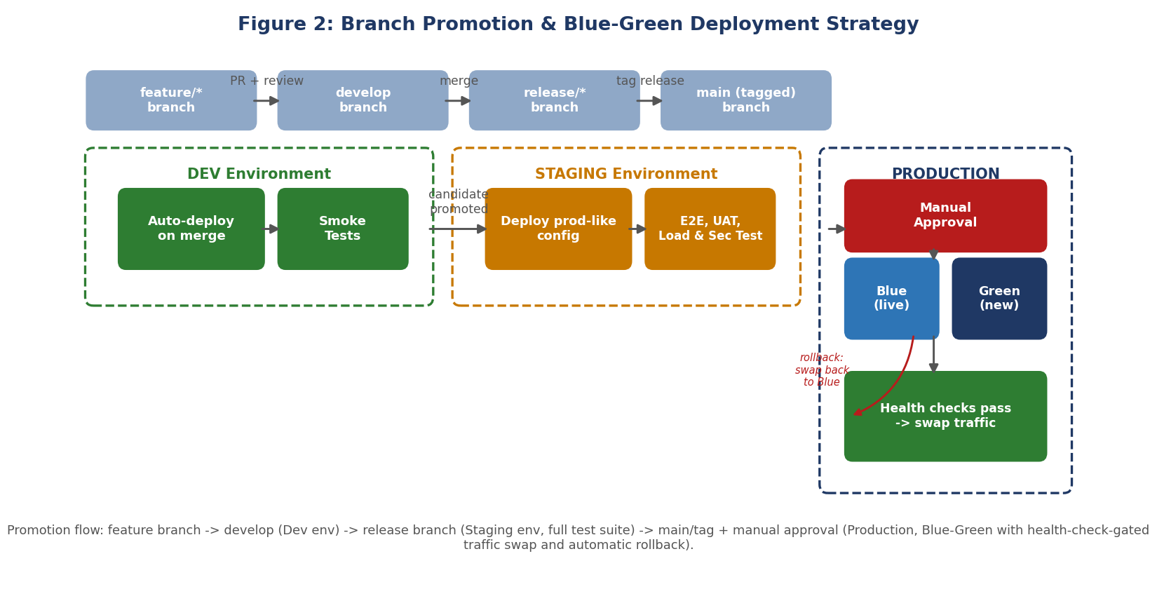
Figure 2: Branch-to-environment promotion and Blue-Green production deployment.
- Development: auto-deployed on every merge to develop; used by developers/QA for early smoke testing; data is fully synthetic.
- Staging (pre-production): mirrors production configuration and mock third-party gateways (SMS/push); the full regression, E2E, load, and security suite runs here; caregiver-alert timing is validated end-to-end before sign-off.
- Production: deployed only from a tagged main build after manual approval, using Blue-Green (or canary) release so the new version serves a small/zero share of traffic until health checks pass, then traffic is swapped with zero downtime.

6. Security, Quality Gates, Notifications & Rollback

6.1 Security & Quality Gates
- Mandatory SonarQube gate: merge is blocked if coverage falls below the agreed threshold or if blocker/critical issues are found.
- Dependency & secret scanning: Snyk/Dependabot and git-secrets run on every PR; a build fails on high-severity vulnerabilities or committed credentials.
- DAST on Staging: OWASP ZAP scans the staging deployment before production promotion.
- Two-person production approval: given the health-adjacent data, production deploys require sign-off from a release owner in addition to the pipeline's automated checks.

6.2 Notifications
- Pipeline stage results (pass/fail) post automatically to a Slack/Teams channel and by email to the commit author.
- Production incidents (failed health checks, elevated alert-delivery latency) page the on-call engineer via PagerDuty.

6.3 Rollback Mechanisms
- Blue-Green swap-back: if post-deploy health checks or error-rate/latency thresholds are breached, traffic is automatically switched back to the previous stable (Blue) version.
- Versioned artifacts: the last N Docker images / mobile builds are retained in the registry so a previous version can be redeployed within minutes.
- Reversible database migrations: schema changes are written to be backward-compatible and paired with a down-migration script.
- Feature flags: risky changes to reminder/escalation logic can be toggled off instantly without a full redeploy.

7. Conclusion
This CI/CD design automates the journey from code commit to production for the Medication Adherence Tracker across its mobile, web, and backend components. Automated unit, integration, E2E, security, and performance testing — combined with a SonarQube quality gate, staged Dev/Staging/Production environments, Blue-Green deployment, and automatic health-check-based rollback — give the team fast feedback while protecting the reliability and safety the system's elderly users and caregivers depend on.

